Y2025/M5/D14 draft

**A quantitative model for the growth of L- or D-peptides at the origin of life**

**Richard Gordon**

Gulf Specimen Marine Laboratory & Aquarium

222 Clark Drive

Panacea, FL 32346 USA

[DickGordonCan@protonmail.com](mailto:DickGordonCan@protonmail.com)

**Hussain Ather**

We have proposed that diurnal PCR-like cycles in positive feedback with thickening of the initial vesicle membranes may have been responsible for the thickening of membranes to the extant thickness and selection for L- or D- membrane peptides (Gordon, 2024, Gordon and Gordon, 2023). We have postulated that day/night cycles producing flat, polygonal shaped, double droplets (Gordon, 2023) were the vesicles in which abiogenesis occurred (Gordon, 2024). These could have led to the near 2D geometry proposed to have led to the exergonic nature of polymerization and crowded “cytoplasm” necessary for extensive polymerizations (Ross and Deamer, 2019, Ross and Deamer, 2016), meeting “the essential requirement of an entropy-promoting large surface/volume ratio (Ross and Deamer, 2019).

Here we propose and simulate a model based on the crowding of peptides during the origin of life. The basic idea is that peptides containing alpha helices whose sequence is hydrophobic and is different from the current thickness of membranes. These enter the membrane once that anchor sequence appears, and select for amphiphiles that are slightly longer or shorter than the thickness of the membrane (Killian, 1998). With membrane thickening, the required length for the anchor increases. Early membranes might have provided the hydrophobic environment that has been postulated at the origin of life (Vitas and Dobovišek, 2025). Peptides lacking these sequences stay within the membrane, perhaps forming bundles due to alignment (Alvarado et al., 2014) and form a prebiotic crowded cytoplasm (Cary et al., 2024, Deamer, 2016, Deamer et al., 2022, Ross and Deamer, 2019, Ross and Deamer, 2016), which entropically favors PCR-like polymerization during wet/dry cycles, of which we have shown that about 1011 might have been available during the origin of life (Gordon and Mikhailovsky, 2021, Gordon and Mikhailovsky, 2024).

The driving force for this process is ultimately the day/night cycling of the Earth. Thus, ours is a nonequilibrium approach, different from the equilibrium approach of (Wang et al., 2025). (While α‑alumina is unlikely to have been present at the origin of life, other Al crystals might have provided catalytic surfaces, per Robert Hazen, personal communication.) Of course, a combination of both processes could have been involved. Equilibrium is limited to short peptides, whereas with 1011 day/night cycles having been available, the nonequilibrium approach is essentially unlimited.

We can take the limitation to be per‑cycle depolymerization p (< 0.5 %) (Oivanen et al., 1998, Ross and Deamer, 2016), for truncating polymerization.

As we have hypothesized that vesicles may have started with at least one configuration being a flat, pancaked polygon (Gordon, 2024), here the size of a polygon will be approximated as a circle of a given diameter, whose thickness will be taken as 0.2 µm, as in some extant Archaea (Gordon et al., 2018). The flat configuration ensures the possibility of cytoplasmic crowding. We do not assume that the vesicles have any form of metabolism or enzymes (Casimo et al., 2024).

Vesicles could have protected their contents from hard UV (Lechuga and Michaelian, 2023).

We will assume that the peptides form one aligned bundle inside the vesicle. This assumption is most likely were the vesicles rectangles 1.5 × as long as wide (Alvarado et al., 2014), but could be approximately correct for other polygonal shapes. However, as the volumes of two of the most common amino acid residues delivered by meteorites are $Glycine \sim 60–65Å^{3}, Alanine \sim 88Å^{3}$, with glycine achiral and alanine chiral (L- or D-) even rounding up 100 $Å^{3}$, a vesicle of 1 µm3 could hold peptides with 1010 total residues. Alanine has the highest propensity to form α-helices, while glycine has the lowest (Pace and Scholtz, 1998). We will assume that primitive peptides were mixtures of D-alanine, L-alanine, and glycine, as representatives of amino acid residues that can form α-helices of either chirality, interrupted by achiral glycine residues. Each α-helix must be pure D-alanine or L-alanine, as they would also interrupt one another. While more complex sequences than runs of D-/L- amino acids might be hydrophobic, we will ignore them for now.

It is possible that a peptide fails to develop an anchor sequence and either exits the vesicle or contributes to its “cytoplasm”.

We will assume for now that the source of amphiphiles was meteorites, though more robust amphiphiles might have been produced on Earth (Apel and Deamer, 2005).

All peptides are assumed to elongate one amino acid residue per wet/dry cycle. If a peptide acquires a hydrophobic sequence long enough to span the membrane, that peptide moves to a D- or L-membrane raft or peptide cap (“peptide aggregation”in Figure 1 of (Killian, 1998)). That “anchoring” sequence is presumed to correspond to the chirality of the existing raft. They are not added to the raft if no anchor any longer matches the membrane thickness. Hydrophobicity requires a sequence of at least four L- or four D- amino acids. As prebiotic membranes were likely nonuniform and leaky, each peptide has some probability of escaping from a vesicle.

Transmembrane anchor helices of 15 to 24+4 amino acid residues have been reported for extant organisms(Killian, 1998). Longer helices may be due to tilting (Killian, 1998), which we will ignore here.

We will assume that the initial thickness of vesicles corresponded to an amphiphile chain length of 8 (Gordon, 2024) and that membrane thickness halts at amphiphile chain length 16 (Gordon, 2024), the latter corresponding to 23 amino acid residues (Table 9, Chapter 7, (Gordon, 2024)). To round to the nearest integer, we will assume that membrane thickness grows from spanning 12 amino acid residues to 23 amino acid residues.

Representing long random chains of D-L-peptides can be compressed for visualization. For instance, for peptides terminating in 4 Ds or Ls:

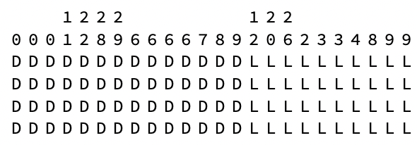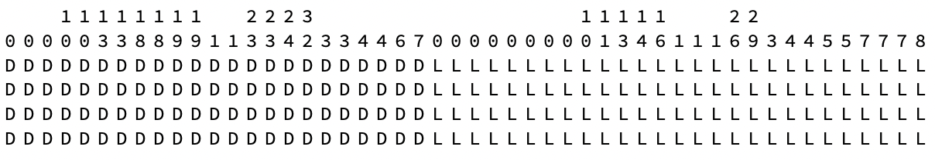

Figure 1. Compact representations of random D-L-peptides with anchors of 4 amino acid residues. Top: D‑peptides form a larger raft. Bottom: L-peptides form the larger raft. Real rafts would of course be two dimensional.

The membrane is represented as 4 Ds or Ls read downwards, the anchor portion of each peptide. These are sorted to represent two peptide rafts of Ds or Ls. The portion of the peptide outside the vesicle is represented as a number of random amino acid residues, with the number read downwards, making for a compact notation. For instance, in another simulation:

1

3

D

D

D

D

has a total length of 13+4 amino acid residues, and represents:

D

L

D

D

L

G

D

D

L

D

L

L

L

D

D

D

D

The random portion above the anchor of 4 Ds is thus only shown compactly by its length of 13 and contains no anchor sequence.

Peptide-peptide interactions between their random portions are not accounted for, though they could stabilize or disrupt a peptide raft. Folding of peptides above the anchor could have similar effects.

Wewill assume that the “hydrophobic mismatch” between membrane anchors and the membrane amphiphiles are mobile within the membrane and that the shorter amphiphiles will eventually be replaced by longer ones from the medium. Thus, the membrane itself is not simulated. A more sophisticated simulation would do this. Many other configurations of the anchor portion of a peptide with a membrane are figured in (Egel, 2009).

The thickening of the membrane itself is presumed to be a stochastic process, increasing or decreasing depending on the average thicknesses of the peptide rafts. To simulate this, the membrane thickness is allowed to accept peptides with anchor length membraneThickness + hydrodynamicMismatch, where the spelling of these variables follows Mathematica conventions. The membrane amphiphiles that accomplish this are assumed to be available outside the vesicle, or to leave the vesicle membrane to adjust to the mean raft anchor thickness. Thus, the mean thickness of the membrane and the rafts are allowed to fluctuate.

However, we presume that there is a maximum stable membrane thickness equivalent to the thickness of modern membranes (Gordon and Gordon, 2022, Gordon and Gordon, 2023, Gordon and Gordon, 2024). Thus, the membrane thickness of an abiotic membrane may do a random walk from its minimumThickness to its maximumThickness. On reaching the maximum, we assume that other processes take over stabilizing the thickness at its maximum. The exact process(es) cannot be specified until the mechanisms leading to halting at the maximum are fully investigated. This is thus similar to the symmetric classical gambler’s ruin problem (Feller, 1950).

Here is an example of rafts with anchors of 5 amino acid residues:

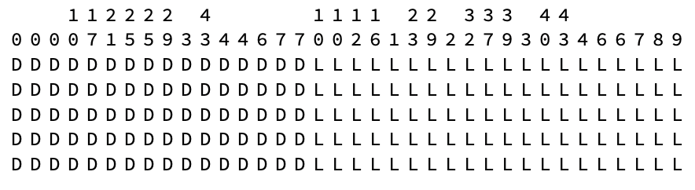

The peptide 40LLLLL is LDLDDLLDDLLDGDLLDDDLLLGLLLDDDLDLDLLDLLLDLLLLL.

This array has anchors varying from 3 to 7, mean 5:

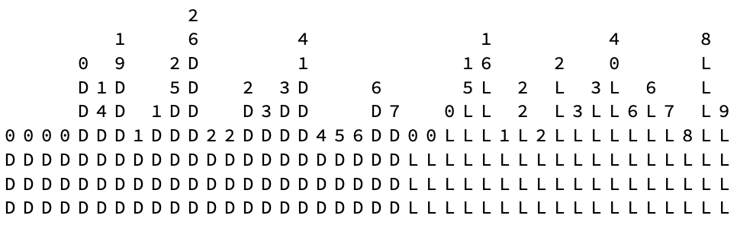

**A solution to the in/out and Lipid Divide problems**

When a peptide has a hydrophobic sequence adequate to insert into the membrane, then the longer part of the peptide could either end up inside or outside the vesicle. If inside, it may not contribute to the S-layer, but it could initiate an inward oriented raft. Wewill assume that such vesicles are unstable relative to vesicles with an outward oriented raft, and thus eventually fall apart. This then provides a solution to the in/out problem of the general orientation of the extant S-layer on the outside of the cell. It also assumes that as soon as a peptide has a long enough hydrophobic sequence, the peptide inserts in the membrane and terminates the peptide’s growth. Further PCR-like cycles apply to the next peptide. This then presents a solution to the Lipid Divide, if we take the first peptide to initiate a raft as having a D embedded sequence for Archaea and an L terminal sequence for Bacteria.

To clarify, there are four possible rafts: D or L inside the vesicle and D or L outside the vesicle. By the formation of an external S-layer (albeit made of assorted peptides before replicating protein synthesis begins) We presume that only the outside configurations are viable. Whether D or L outside rafts persist, wewill assume depends on their relative sizes. In the literature, the word “raft” often refers to lipid rafts (Fan et al., 2010), which we are presently ignoring for simplicity.

The longest known protein so far is titin in mouse at 35,213 amino acid residues (Swiss Institute of Bioinformatics, 2024, Wikipedia, 2024). Most combinatorics formulae only take into account binary sequences (Bloom, 1996). We therefore generate random sequences of three characters, D, L, and G, representing D-amino acids, L-amino acids and achiral amino acids (glycine) respectively, with proportions that consider any initial enantiomeric excess and frequency of glycine in extant proteins (range 1-4% (van der Rest and Fietzek, 1982) to 6.8% (Martz, 2020), or, say, 1-7%). Those sequences containing runs of D or L between 12 and 24 amino acid residues will be assumed to imbed in the vesicle’s membrane.

While the non-embedding random parts of the sequences will be ignored, some might account for enzymatic activity.

Each peptide, embedded or not, will be presumed to have required 35,213 PCR-like cycles, an overestimate. As 1011 PCR-like cycles might have been available during the origin of life (Gordon, 2024, Gordon and Mikhailovsky, 2021), the overestimate of time needed to generate such long random sequences is not significant. During this time, assuming one PCR-like cycle per amino residue, up to 2,839,860 random peptides of this length could have been generated, 3000 times the number needed to coat a 1µm vesicle with peptides, which can be estimated from Figures 4.10 and 5.10 in (Gordon, 2024) as *O*(1000-2000). Put another way, about 1/3000 of the time needed for the origin of life might have been needed for the processes described here, or less.

To begin, we’ve written a program in Mathematica that grows random peptides, terminating them in this case when their terminal sequence is LLLLL or DDDDD. They are then sorted by their end sequences, representing two rafts of peptides ending in Ls or Ds.

$$\begin{matrix} & & & & & & \\ & & & & & & \\ & & & & & & \\ & & & & & & \\ & & & & & & \\ & & & & & & \\ & & & & & & \\ & & & & & & \\ & & & & & & \\ & & & & & & D \\ & & & & & & D \\ & & & & & & L \\ & & & & & & L \\ & & & & & & D \\ & & & & & & L \\ & & & & & & D \\ & & & & & & D \\ & & & & & & D \\ & & & & & & D \\ & & & & & & L \\ & & & & & & L \\ & & & & & & D \\ & & & & & & D \\ & & & & & & D \\ & & & & & & L \\ & & & & & & L \\ & & & & & & D \\ & & & & & & D \\ & & & & & & 0 \\ & & & & & & L \\ & & & & & & D \\ & & & & & & L \\ & & & & & & L \\ & & & & & & D \\ & & & & & & L \\ & & & & & & D \\ & & & & & & D \\ & & & & & & D \\ & & & & & & L \\ & & & & & & D \\ & & & & & & L \\ & & & & & & L \\ & & & & & & D \\ & & & & & & L \\ & & & & & & D \\ & & & & & & D \\ & & & & & & L \\ & & & & & & D \\ & & & & & & L \\ & & & & & & L \\ & & & & & & L \\ & & & & & & L \\ & & & & & & D \\ & & & & L & & D \\ & & & & D & & L \\ & D & & & D & & L \\ & L & & & D & & D \\ & L & & & L & & L \\ & D & & & D & & D \\ & L & & & D & & L \\ & D & & & D & & D \\ & D & & & L & & L \\ & L & & & L & & D \\ D & L & & & D & & L \\ D & D & & & L & & 0 \\ L & L & & L & D & & D \\ L & D & & D & L & & L \\ L & L & L & D & L & & D \\ L & D & L & L & L & L & D \\ D & D & D & D & D & D & D \\ L & L & L & L & L & L & L \\ L & L & L & L & L & L & L \\ L & L & L & L & L & L & L \\ L & L & L & L & L & L & L \\ L & L & L & L & L & L & L\end{matrix},\begin{matrix}L & & \\ L & & \\ D & & \\ D & & \\ L & & \\ D & & \\ D & & \\ L & & \\ L & & \\ L & & \\ D & & \\ L & & \\ L & & D \\ L & & L \\ L & & D \\ D & & D \\ L & & D \\ D & & L \\ D & & L \\ D & & D \\ L & & D \\ L & & D \\ D & & L \\ L & & D \\ D & & L \\ L & & L \\ L & & L \\ L & & D \\ D & & D \\ L & & L \\ L & & L \\ D & & D \\ D & & L \\ D & & D \\ L & & D \\ D & & L \\ L & & L \\ L & & D \\ L & & D \\ L & & L \\ D & & L \\ L & & D \\ D & & L \\ L & & D \\ D & & D \\ L & & L \\ L & & D \\ L & & D \\ D & & L \\ L & & L \\ L & & D \\ L & D & L \\ L & D & L \\ D & D & D \\ L & L & D \\ D & D & L \\ L & D & D \\ 0 & D & 0 \\ L & L & L \\ L & L & L \\ D & D & L \\ L & D & L \\ D & D & D \\ L & D & L \\ L & L & L \\ D & L & D \\ L & D & D \\ L & D & D \\ D & L & D \\ L & L & L \\ D & D & D \\ D & D & D \\ D & D & D \\ D & D & D \\ D & D & D\end{matrix}\}$$

Figure 2. 10 random peptides were generated, terminated when they acquired 5 Ls or 5 Ds, and then grouped together. For each, the first amino acid residue is at the top. They are aligned to represent two rafts anchored in a thin membrane. The achiral amino acid residue occurs here with 1% frequency and is represented by 0s.

**A 1D model**

To gain some intuition about the configuration of membranes in which peptide rafts float in the membrane, to model their dynamics, we created a 1D model (Figure 2).



Figure 2. Membrane amphiphiles are designated by the letter m, peptides by the letter p. The number beneath each letter, read vertically, is the length measured in amino acid residues lengths. In the case of peptides, this is the length of the anchor. These lengths are arranged so that the mp and pm edges have minimum hydrophobic mismatch. The lengths were generated randomly over the range [4,24].

Extending this to a 2D membrane containing a 2D peptide raft requires the following considerations:

1. The width of the amphiphiles and the peptide anchors may not be the same;
2. The binding energies p-p, m-m, and m-p must be specified;
3. The temperature dependence of those binding energies must be specified;
4. The pool of amphiphiles outside the membrane has to be ascertained from meteorite data;
5. The mechanism of peptide synthesis needs to be specified;
6. The rearrangements that occur as amphiphiles and peptides are added and removed need to be understood;
7. The rates of those additions/removals need to be estimated.

Discuss:

(Zhu and Szostak, 2009)

**References**

Alvarado J, Mulder BM, Koenderink GH. Alignment of nematic and bundled semiflexible polymers in cell-sized confinement. Soft Matter 2014;10(14):2354–2364; doi: 10.1039/c3sm52421c.

Apel CL, Deamer DW. The formation of glycerol monodecanoate by a dehydration/condensation reaction: Increasing the chemical complexity of amphiphiles on the early earth. Orig Life Evol Biosph 2005;35(4):323–332; doi: 10.1007/s11084-005-2046-8.

Bloom DM. Probabilities of clumps in a binary sequence (and how to evaluate them without knowing a lot). Math Mag 1996;69:366–372.

Cary F, Deamer D, Damer B, et al. Could life have started on Mars? Planetary conditions that assemble and destroy protocells. Life 2024;14:#415; doi: 10.3390/life14030415.

Casimo G, Micca Longo G, Longo S. Beyond homochirality: Computer modeling hints of heterochiral proteins in early and extraterrestrial life. Astrobiology 2024;25(1):22–31; doi: 10.1089/ast.2024.0072.

Deamer D. Membranes and the origin of life: A century of conjecture. Journal of Molecular Evolution 2016;83(5-6):159–168; doi: 10.1007/s00239-016-9770-8.

Deamer D, Cary F, Damer B. Urability: A property of planetary bodies that can support an origin of life. Astrobiology 2022:<https://doi.org/10.1089/ast.2021.0173>.

Egel R. Peptide-dominated membranes preceding the genetic takeover by RNA: Latest thinking on a classic controversy. Bioessays 2009;31(10):1100–1109; doi: 10.1002/bies.200800226.

Fan J, Sammalkorpi M, Haataja M. Influence of nonequilibrium lipid transport, membrane compartmentalization, and membrane proteins on the lateral organization of the plasma membrane. Physical Review E 2010;81(1); doi: 10.1103/PhysRevE.81.011908.

Feller W. An Introduction to Probability Theory and Its Applications. John Wiley & Sons: New York, NY, USA; 1950.

Gordon R. When we were all triangles: Shape in the origin of life via abiotic-shaped droplets to living, polygonal Archaea during the Abiocene [Chapter 5]. In: Conflicting Models for the Origin of Life [COLF, Volume in the series: Astrobiology Perspectives on Life of the Universe, Series editors: Richard Gordon & Joseph Seckbach, Wiley-Scrivener]. (Smoukov S, Seckbach J, Gordon R eds.) Wiley-Scrivener: Beverly, Massachusetts, USA, 2023; pp. 213–262.

Gordon R. Origin of Life via Archaea: Shaped Droplets to Archaea First, With a Compendium of Archaea Micrographs [OOLA, Volume in the series Astrobiology Perspectives on Life of the Universe, Eds. Richard Gordon & Joseph Seckbach] <https://www.scrivenerpublishing.com/cart/title.php?id=910>. Wiley-Scrivener: Beverly, Massachusetts, USA; 2024.

Gordon R, Gordon NK. How to make an S-layer at the origin of life: A possible origin of proteins. In: Emergence in Biological Systems: Challenges to Bridging Hierarchies, March 1-3. RIKEN Center for Biosystems Dynamics Research (BDR): Japan, 2022.

Gordon R, Gordon NK. How to make a transmembrane domain at the origin of life: A possible origin of proteins [Chapter 7]. In: Conflicting Models for the Origin of Life [COLF, Volume in the series Astrobiology Perspectives on Life of the Universe, Eds. Richard Gordon & Joseph Seckbach]. (Smoukov SK, Seckbach J, Gordon R eds.) Wiley-Scrivener: Beverly, Massachusetts, USA, 2023; pp. 131–174.

Gordon R, Gordon NK. How to make a transmembrane domain at the origin of life: A possible origin of proteins [Chapter 7]. In: Origin of Life via Archaea: Shaped Droplets to Archaea First, With a Compendium of Archaea Micrographs [OOLA, Volume in the series Astrobiology Perspectives on Life of the Universe]. (Gordon R, Seckbach J eds.) Wiley-Scrivener: Beverly, Massachusetts, USA, 2024; pp. 229–284.

Gordon R, Hanczyc MM, Denkov ND, et al. Emergence of polygonal shapes in oil droplets and living cells: The potential role of tensegrity in the origin of life. In: Habitability of the Universe Before Earth [Volume 1 in series: Astrobiology: Exploring Life on Earth and Beyond, eds. Pabulo Henrique Rampelotto, Joseph Seckbach & Richard Gordon]. (Gordon R, Sharov AA eds.) Elsevier B.V.: Amsterdam, Netherlands, 2018; pp. 427–490.

Gordon R, Mikhailovsky G. There were plenty of day/night cycles that could have accelerated an origin of life on Earth, without requiring panspermia [Chapter 11]. In: Planet Formation and Panspermia: New Prospects for the Movement of Life through Space [PNSP, Volume in the series Astrobiology Perspectives on Life of the Universe, Series Editors: Richard Gordon & Joseph Seckbach]. (Vukotić B, Seckbach J, Gordon R eds.) Wiley-Scrivener: Beverly, Massachusetts, USA, 2021; pp. 195–206.

Gordon R, Mikhailovsky G. By the light of the Moon [Chapter 2]. In: Origin of Life via Archaea: Shaped Droplets to Archaea First, With a Compendium of Archaea Micrographs [OOLA, Volume in the series Astrobiology Perspectives on Life of the Universe]. (Gordon R, Seckbach J eds.) Wiley-Scrivener: Beverly, Massachusetts, USA, 2024; pp. 33–40.

Killian JA. Hydrophobic mismatch between proteins and lipids in membranes. Biochim Biophys Acta 1998;1376(3):401–415; doi: 10.1016/s0304-4157(98)00017-3.

Lechuga I, Michaelian K. Fatty acid vesicles as hard UV-C shields for early life. Foundations 2023;3(1):99–114.

Martz E. Amino acid composition. 2020. Available from: <https://proteopedia.org/wiki/index.php/Amino_acid_composition>.

Oivanen M, Kuusela S, Lönnberg H. Kinetics and mechanisms for the cleavage and isomerization of the phosphodiester bonds of RNA by Brønsted acids and bases. Chem Rev 1998;98(3):961–990; doi: 10.1021/cr960425x.

Pace CN, Scholtz JM. A helix propensity scale based on experimental studies of peptides and proteins. Biophysical Journal 1998;75(1):422–427.

Ross D, Deamer D. Prebiotic oligomer assembly: What was the energy source? Astrobiology 2019;19(4):517–521; doi: 10.1089/ast.2018.1918.

Ross DS, Deamer D. Dry/wet cycling and the thermodynamics and kinetics of prebiotic polymer synthesis. Life-Basel 2016;6(3):#28; doi: 10.3390/life6030028.

Swiss Institute of Bioinformatics. ProtParam - Results: TITIN_MOUSE (A2ASS6). 2024. Available from: <https://web.expasy.org/cgi-bin/protparam/protparam1?A2ASS6@noft@>.

van der Rest M, Fietzek PP. A comprehensive approach to the study of collagen primary structure based on high‐performance liquid chromatography. Eur J Biochem 1982;125(3):491–496.

Vitas M, Dobovišek A. A possible origin of life in nonpolar environments. BioSystems 2025;247:#105384; doi: <https://doi.org/10.1016/j.biosystems.2024.105384>.

Wang R, Remsing RC, Klein ML, et al. On the role of α-alumina in the origin of life: Surface-driven assembly of amino acids. Science Advances 2025;11(15):#eadt4151; doi: 10.1126/sciadv.adt4151.

Wikipedia. Titin. 2024. Available from: <https://en.wikipedia.org/wiki/Titin>.

Zhu TF, Szostak JW. Coupled growth and division of model protocell membranes. Journal of the American Chemical Society 2009;131(15):5705–5713; doi: 10.1021/ja900919c.